By the
[INSERT TITLE OF LOCAL OR STATE OFFICIAL]
of
[INSERT CITY/TOWN/STATE]
WHEREAS, the safety and security of the citizens of [State/County/Community Name] and surrounding areas are vitally important; and
WHEREAS, a large percentage of our citizens regularly drive or ride in motor vehicles on our roadways; and
WHEREAS, the use of seat belts in passenger vehicles saved an estimated 14,955 lives of occupants 5 and older in 2017; and
WHEREAS, regular seat belt use is the single most effective way to reduce fatalities in motor vehicle crashes;
WHEREAS, the use of seat belts is supported by the laws of [STATE/COMMUNITY NAME];
WHEREAS, May 20 through June 2, 2019, has been selected as the national Click It or Ticket mobilization enforcement period;
WHEREAS, across the country law enforcement officers will actively be participating in the mobilization to ensure all motor vehicle occupants are buckled up day and night to reduce the risk of injury and death caused in traffic crashes;
AND WHEREAS, increased enforcement of seat belt laws coupled with publicity has proven to be an effective method to increase seat belt use rates and decrease fatal crashes;
NOW, THEREFORE, I, [NAME, TITLE, JURSIDICTION], do hereby proclaim and announce May 20 through June 2, 2019, as the Click It or Ticket mobilization in [state/county/community], and urge all citizens to always wear seat belts when driving or riding on our roadways.

IN WITNESS WHEREOF, I have hereunto set my hand on behalf of [State/County/Community Name].

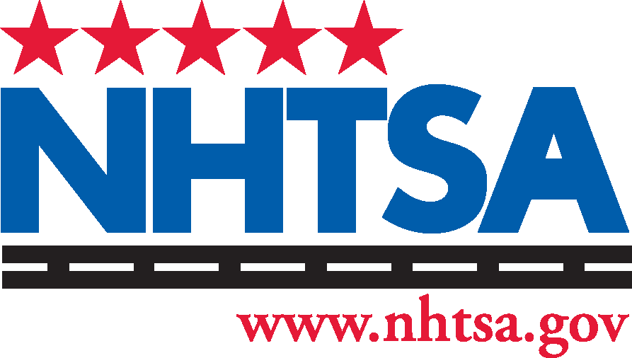
______________________________________

Insert State logo here.
[Name, Title, Jurisdiction]
______________________________________
[Date]
TP00019c-021219-v1

