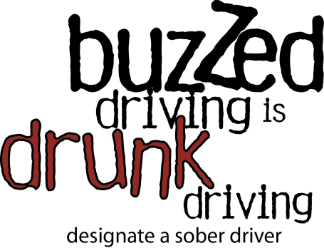
Halloween Campaign
Sample Press Release

On Halloween, and Every Day, Buzzed Driving Is Drunk Driving
[Local Organization] Reminds Halloween Partiers of the Dangers of Drinking and Driving

[City, State]— Halloween is a time for making memories, not causing nightmares. This Halloween, [Local Organization] is reminding Halloween partiers that Buzzed Driving Is Drunk Driving. Stay safe—and help keep others safe—by refraining from drunk driving. In 2015, there were 55 people killed in drunk-driving-related crashes. If your Halloween party involves alcohol, it’s imperative that you make a plan to get home without getting behind the wheel.

“It’s so important to make a plan before heading out to the Halloween festivities,” said [Local Leader]. “Even one drink can impair judgement. This is why it’s essential to have a plan for how you’ll safely get home after your night of partying, before you ever head out for your event. Remember: Buzzed Driving Is Drunk Driving.”

According to the National Highway Traffic Safety Administration (NHTSA), 45 percent of all people killed in motor vehicle crashes on Halloween night (6 p.m. October 31 – 5:59 a.m. November 1) from 2011 to 2015 were in crashes involving a drunk driver. Children out trick-or-treating and the parents accompanying them are also at risk, as 36 percent of fatal pedestrian crashes on Halloween night (2011-2015) involved drunk drivers. Younger drivers are most at risk: The 21-to-34-year age group accounted for the most fatalities (64%) in drunk-driving-related crashes during Halloween night in 2015.

It is illegal everywhere in America to drive with a blood alcohol concentration (BAC) of .08 or higher. In 2015, there were 10,265 people killed in drunk-driving-related crashes. Even if you drive drunk and aren’t killed or seriously injured, you could end up paying as much $10,000 for a DUI.

Buzzed Driving is Drunk Driving, so follow these simple tips for a safe and happy Halloween:
- Remember that it is never okay to drink and drive. Even if you’ve had one alcoholic beverage, designate a sober driver or plan to use public transportation to get home safely.
- Download NHTSA’s SaferRide mobile app, available on Google Play for Android devices: (https://play.google.com/store/apps/details?id=com.nhtsa.SaferRide&hl=en), and in Apple’s iTunesStore for iOS devices: (https://itunes.apple.com/us/app/saferride/id950774008?mt=8). SaferRide allows users to call a taxi or a predetermined friend, and identifies the user’s location so he or she can be picked up.
- Use your community’s sober ride program [Insert your local sober ride program specifics here].
- If you see a drunk driver on the road, contact [Local Law Enforcement].
- Have a friend who is about to drink and drive? Take the keys away and make arrangements to get your friend home safely.

For more information, please visit www.TrafficSafetyMarketing.gov.

