WORKPLACE

DRIVER SAFETY TOOLKIT

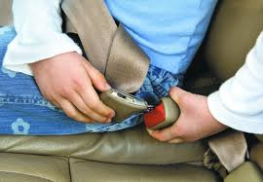

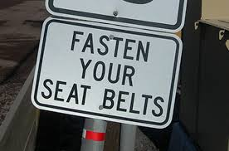

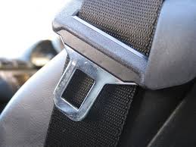

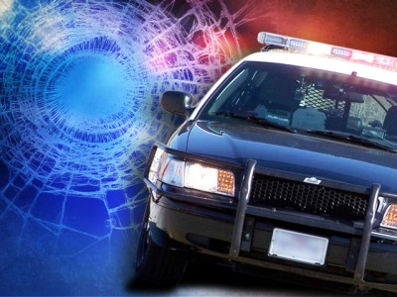

An innovative way to help save lives and control the significant costs associated with vehicle crashes in the workplace.



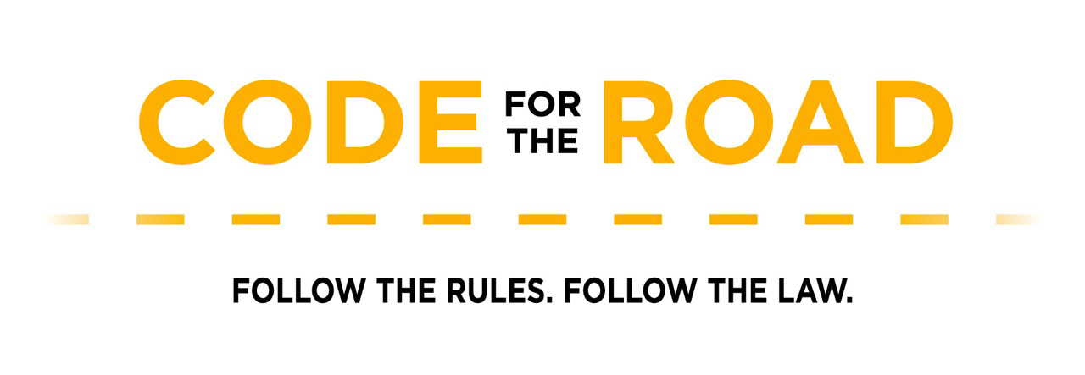



Provided by:

North Dakota Association of Counties Traffic Safety Outreach Program North Dakota Department of Transportation

701-364-9402

This document was created to provide guidance in developing and establishing a worksite traffic safety program. The guidelines serve as a basis for developing an organization-specific plan and include the crucial components that are essential in building a successful worksite campaign.

This document is advisory in nature, informational in content, and is intended to assist employers in providing a safe and healthful workplace environment.

**WORKPLACE DRIVER SAFETY TOOLKIT TABLE OF CONTENTS**

**Table of Contents**

**Introduction**

Toolkit Goals............................................................................................................................................. 1

Cost of Motor Vehicle Crashes to Employers ........................................................................................... 1

Benefits of Workplace Driver Safety Program .......................................................................................... 2

Using the Workplace Driver Safety Toolkit................................................................................................ 2

**Section I: Creating a “Driver Safety Conscious” Culture In The Workplace**

Step 1: Implement Written Policies and Procedures ............................................................................... 3

Step 2: Employee Involvement – Garner Support from All Levels of the Organization............................ 3

Step 3: Driver Safety Agreements …………………......................................................................................... 4

Step 4: Motor Vehicle Record (MVR) Checks ......................................................................................... 5

**Section II: Increasing Employee Seat Belt Use**

Step 1: Educate ....................................................................................................................................... 6

Step 2: Encourage.................................................................................................................................... 7

Step 3: Enforce........................................................................................................................................ 8

**Resources**

Cost of Crashes to Employers Fact Sheet & Worksheet ........................................................ i-ii

Observational Seat Belt Instructions & Survey Form .............................................................iii- iv

Sample Workplace Driver Safety Policies .............................................................................. v

Sample Employee Driver Agreement

Sample Seat Belt Use Policies

Sample Alcohol/Drug Policies

Sample Distracted Driving Policies

Sample Driving Record Review Policies

Sample Receipt of Driver Safety Policy Statement

Idea Starters – Activities to Encourage Seat Belt Use ............................................................ vi

Idea Starters – Examples of Key Messages to include in an Education Campaign ................ vii

Safe Driving Fact Sheet.......................................................................................................... vii

Seat Belt Myths……………………………………………………………………………………………………………….. viii

Organizing Car Seat Checkups ................................................................................................ viii

1 **WORKPLACE DRIVER SAFETY TOOLKIT INTRODUCTION**

**INTRODUCTION**

Employers bear the cost of traffic related injuries that occur both on and off the job. [1]. Many crashes occur during the workday or during the commute to and from work. Seat Belt use is the number one way to prevent traffic related injury and death. Whether you manage a fleet of vehicles, oversee a mobile sales force, have employees who drive on the job or simply employ commuters, implementing a workplace driver safety program to encourage employees to buckle up can greatly reduce their risk of injury or death and help protect your company’s bottom line.

**Toolkit Goals**

The contents of this toolkit will help employers develop and implement a workplace driver safety program to encourage employee seat belt use and safe driving behaviors both on and off the job. This toolkit can be used for any workplace, regardless of size, number of vehicles involved, travel destination or use of personal employee or company vehicles.

By applying the recommendations in this toolkit, employers will:

* Create a “driver safety conscious culture” in the workplace
* Implement policies and procedures that support safe driving behaviors
* Increase the employee seat belt use rate

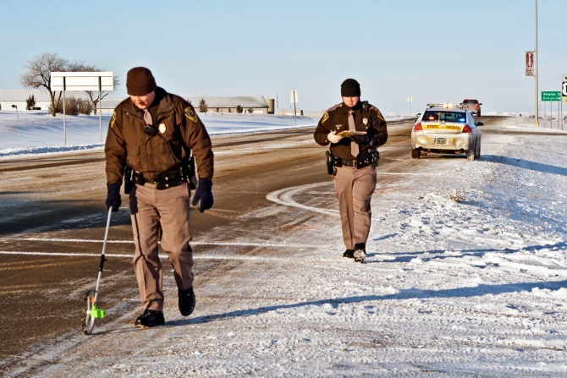

The following sections provide recommendations and tools for creating an effective workplace driver safety program. These recommendations were adapted from “Guidelines for Employers to Reduce Motor Vehicle Crashes” - a joint publication of the Network of Employers for Traffic Safety (NETS), National Highway Traffic Safety Administration (NHTSA) and the Occupational Safety and Health Administration (OSHA) - a proven guide for helping employers reduce motor vehicle crashes among employees.

**Cost of Motor Vehicle Crashes to Employers**

Motor vehicle crashes are a leading cause of death and injury for all ages. Crashes on and off the job have far-

reaching financial, physical and psychological effects on employees, their co-workers, families, and employers.

Motor vehicle crashes, in the workplace and in the private lives of employees, present significant costs to employers. On average they cost employers $60 billion a year in medical care, legal expenses, property damage, and lost productivity. They drive up the cost of benefits such as workers’ compensation, Social Security, private health insurance and disability insurance. They also drive up expenses for company overhead involved in administering these programs.

The average crash occurring on-the-job costs an employer $16,500. When a worker has an on-the-job crash that results in an injury, the cost to their employer can rise above $76,000. Costs can exceed $500,000 when a fatality is involved. Off-the-job crashes are costly to employers as well. Production time lost due to off-the job crash related injuries totaled nearly 225 million days in 2007, compared with 75 million days lost by workers injured on-the-job. Off-the-job crash related injuries suffered by workers cost the nation at least

$246.8 billion in 2007.[2] Focusing on preventing both on and off-the-job crashes is worthwhile investment for any employer.

2 **WORKPLACE DRIVER SAFETY TOOLKIT INTRODUCTION**

The good news is that crashes are largely preventable. Recognizing the opportunity that they have to save lives; a growing number of employers are creating workplace driver safety programs in their companies. No organization can afford to ignore a major problem that has such a serious impact on both the company and the personal lives of employees.

**To Do: Calculate cost of crashes involving employees.**

[Calculate the cost](http://trafficsafety.org/road-safety-resources/public-resources/cost-of-motor-vehicle-crashes-to-employers-2015/) of employee involved Motor Vehicle Crashes to your organization.

*Use the “Cost of Crashes to Employers’ fact sheet and worksheet on pages i-ii in the Resource*

*Section of this guide.*

**Benefits of Workplace Driver Safety Programs**

Employees are a company’s most valuable asset. Workplace driver safety programs not only make good business sense but are also a good employee relations tool. They show that employers care about their employees.

Workplace traffic safety programs are designed to keep employees and those whom they share the road with safe. These programs work to change driver attitudes, improve behavior, and increase skills to build a “driver safety conscious” culture and encourage employees to engage in safe driving practices. By instructing your employees in basic safe driving practices and then rewarding safety-conscious behavior, you can help them, and their families avoid tragedy.

**Using the Workplace Driver Safety Toolkit**

This guide provides recommendations and tools for building a successful driver safety program in the workplace.

Successful workplace driver safety programs increase seat belt use, and encourage safe driving behaviors through policies, education, encouragement and enforcement.

These recommendations can be used by any organization, regardless of size, number of vehicles involved, travel destination or whether employees drive company or personal vehicles for work purposes. Following these recommendations will help create a driver safety conscious culture in the workplace, keep employees safe on the road and keep crash related costs to employers as low as possible.

3 **WORKPLACE DRIVER SAFETY TOOLKIT SECTION 1: CREATING A “DRIVER SAFETY CONSCIOUS” CULTURE IN THE WORKPLACE**

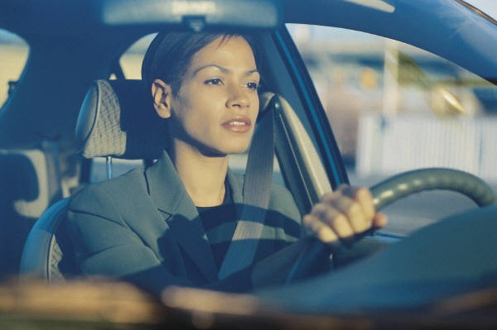**SECTION I: CREATING A “DRIVER SAFETY CONSCIOUS” CULTURE IN THE WORKPLACE**

Creating a “driver safety conscious” workplace is the first step in developing

a sound workplace driver safety program. Making safe driving a part of an

organization’s culture and value system creates an environment where safe

driving is expected, supported and rewarded. In “driver safety conscious”

workplaces, traffic safety education is readily received and is proven to be

more effective in changing employee behavior.

**Step 1: Implement Written Policies and Procedures**

Written driver safety policies and procedures emphasize an organization’s

commitment to reducing traffic-related injury and death and are effective tools for creating a “driver safety conscious” culture in the workplace.

**To Do: Implementing Written Policies**

1. Create a clear, comprehensive and enforceable set of traffic safety policies.

*See Sample Workplace Driver Safety Policies on pages v-viii in the Resource section of this guide.*

A. Examples of workplace traffic safety policies i. Mandatory seat belt use policies

ii. Periodic driving record review policies iii. Employee responsible driving contracts iv. Alcohol/drug use policies

v. Distracted Driving policies

vi. Policies that support the development of work schedules/loads that allow for enough travel

time for employees to obey speed limits and drive safely

2. Get employee support and buy-in.

*See Section i. Step 2: “Employee Involvement” on page 3.*

3. Post policies throughout the workplace, distribute copies periodically, discuss them at company meetings, and integrate them into the orientation process for new hires.

4. Offer employees incentives for sticking to the rules and point out the consequences of disregarding them.

*See Section ii. Step 2: “Encourage” on page 7.*

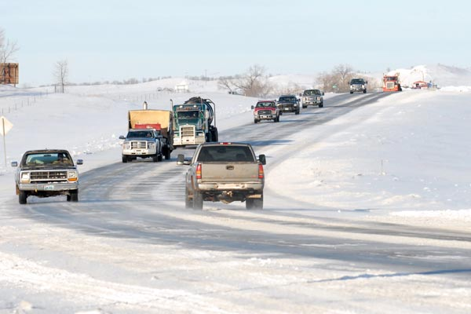

**Step 2: Employee Involvement—Garner Support from all Levels of the Organization**

Ensuring that employees throughout all levels of an organization buckle up and

practice safe driving behaviors requires the attention and buy in of top-level

management. Senior management can provide leadership, set policies, and allocate

resources (staff and budget) to create a “driver safety conscious” culture in the

workplace. Actively encouraging employee participation and involvement at all levels

of the organization is also good practice and will help the effort to succeed.

**To Do: For Employee Involvement**

1. Educate senior management on the importance of seat belt use and safe driving.

2. Think of other ways to garner the support of upper level management.

3. Stress the importance and impact of seat belt use and safe driving to the organization as a whole.

**Tips for Building Employee Support** *(Minnesota Safety Council)*

Don’t spring a policy on employees as a surprise. This could result in long-term negativity and lack of respect for the policy. Hold open meetings with employees to discuss the need for a policy before the policy is implemented. Request feedback



(anonymous or open).

Introduce the policy to all employees only with the support of senior management. Employees must see and hear that top management supports the policy. Employees will sense the level of commitment.

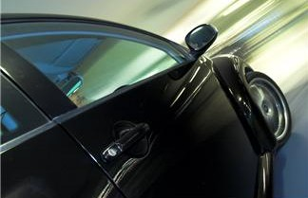

Have a mix of senior management, front-line supervisors, union representatives and other employees serve as spokespeople for the new policy.

If unions are involved hold a pre-meeting with the union steward and reps to gain their support.



Give employees the opportunity to discuss potential barriers, conflicts, beliefs and their doubts related to the policy.



Include employees in decision making. Ask them to offer solutions



to other employees’ objections.

Employees may have concerns about job productivity. Be clear about management’s priority for employee and public safety, and



challenge employees to find solutions to productivity issues.

Involve employees in deciding how to monitor compliance and consequences of non-compliance.

After policy implementation, communicate positive results to employees. Consider surveying impact on productivity and share the results. The results are likely to be more positive than people expect.



**Step 3: Driver Safety Agreements**

Establish a contract with all employees who drive personal or company vehicles for work purposes. By signing an agreement,

employees acknowledge awareness and understanding of the organization’s driver safety policies, procedures, and expectations and

agree to follow them.

**To Do: Employee Safe Driving Agreement**

1. Create an agreement that outlines the driver safety expectation and policies your organization has for its employees.

2. Integrate the signing of the agreement into the new hire process.

*See Sample Employee Driver Agreement and Receipt of Driver Safety Policy Statement on pages v and viii in the Resource section of this guide.*

**Step 4: Motor Vehicle Record (MVR) Checks**

Check the driving records of all employees who drive for work purposes. Identifying potential hires with a poor driving record is important, as they are likely to drive less safely than those with good driving records. Current employee MVRs should be reviewed periodically to ensure that good driving records are maintained.

**To Do: Check Employee Motor Vehicle Records**

1. Review MVRs upon hire, following a collision, and notification of a citation. Employee Motor Vehicle Records can be obtained from the North Dakota Department of Transportation (NDDOT). Employee’s full name, address, date of birth, social security number, and driver license number are required to make the request.

Obtain a 3-year motor vehicle record online for a fee of $3.00. Visit <http://www.dot.nd.gov/public/licensing.htm>. Go under “Driver -Online Services”, then click “Online Driving Record”.

2. Clearly define the number and/or type of violations an employee/driver can have before losing the privilege of driving for work.

6 **WORKPLACE DRIVER SAFETY TOOLKIT SECTION II: INCREASING EMPLOYEE SEAT BELT USE**

**SECTION II: INCREASING EMPLOYEE SEAT BELT USE AND IMPROVING DRIVER SAFETY PRACTICES**

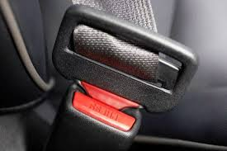

With a "driver safety conscious” culture in place, the stage is set to begin work to improve employee seat belt use and encourage safe driving practices. Successful programs do three things: educate, encourage and enforce. Educate employees on the importance and impact of seat belt use. Use reminders, incentives and reward to encourage them to turn their new knowledge into action. Lastly, take measures to enforce these new behaviors to help employees maintain them.

**Step 1: Educate**

Employers have the power to protect their business by educating employees about safe driving practices, especially seat belt use. Even experienced drivers benefit from periodic training and reminders about safe driving practices. Provide seat belt and safe driving education for employees throughout all levels of the organization. Give employees the facts about the effectiveness of, need for, and the impact of seat belt use and safe driving practices for both themselves and the company. Education can be offered in many different formats such as all staff meetings, trainings, online learning modules, presentations etc. Use the format best fit for your organization.

**To Do: Establish an employee seat belt use rate.**

To monitor your progress in increasing employee seat belt use, conduct seat belt surveys at company parking facilities’ entrances before and after the education campaign. Seat Belt Observational Surveys are simple, short observational surveys and are easy to perform.

*See the Seat Belt Survey instructions and survey form on pages iii-iv in the Resource section of this guide.*

**To Do: Develop goals and messages for your company’s traffic safety education campaign.**

The central focus of the education campaign should be to increase employee seat belt use and encourage safe driving. The campaign should educate employees about the need for and life-saving effectiveness of seat belts. Use the Occupational Seat Belt Fact Sheet to help develop messages for your company’s campaign.

*See: Examples of Key Messages to include in an Education Campaign” on page x in the Resource section of this guide. See the “Safe Driving Fact Sheets” on page xi in the Resource section of this guide.*

**To Do: Launch the campaign! Share educational messages with employees.**

Educate employees using the seat belt and safe driving messages. There are many effective ways to educate employees, i.e. trainings, presentations, online learning modules, mandatory readings etc. Use the format best fit for your organization.

7 **WORKPLACE DRIVER SAFETY TOOLKIT SECTION II: INCREASING EMPLOYEE SEAT BELT USE**

**To Do: Reinforce educational messages using visual reminders and activities.**

Keep employees exposed to key campaign messages using posters, magnets, e-mails or other visual reminders and engaging activities. Activities and reminders should motivate employees to act on the information learned during the campaign. Reminder Idea Starters:



Post “Buckle Up!” or Safe Driving refrigerator and car magnets Display “Buckle Up!” or Safe Driving posters in the workplace Distribute “Buckle Up!” or Safe Driving air fresheners

Include “Buckle Up!” or Safe Driving reminders in e-mails and paycheck stubs

Post “Buckle Up!” signs or use a “Buckle Up” ground stencil in the employee parking lot

*See the “Idea Starters—Activities to Encourage Seat Belt Use” sheet on page ix of the Resource section of this guide for*

*additional suggestions.*

**Step 2: Encourage**

Develop incentive/reward programs to encourage employees to retain and act on the driver safety information from the

education campaign. Reward and incentive programs typically involve recognition, special privileges or the use of incentives to motivate employees to reach a pre-determined goal or increase participation in a program.

**To Do: Find the right size program.**

Incentive/reward programs can be implemented across the organization as a whole or tailored to fit an individual division or workgroup.

**To Do: Set a goal for the incentive/reward program.**

Examples include: Buckle up for a certain length of time (days, weeks), take additional driver training, buckle up during a random seat belt survey, sign a safe driving pledge, etc.

**To Do: Develop incentives and rewards.**

The program is only effective if the employees value the incentives/rewards given. Engage employees throughout all levels of the organization to identify the incentives/rewards.

**To Do: Promote the program.**

Make employees aware of the program. Include information on how to get involved, earn and use incentives/rewards.

8 **WORKPLACE DRIVER SAFETY TOOLKIT SECTION II: INCREASING EMPLOYEE SEAT BELT USE**

**Step 3: Enforce**

**Enforcement Idea Starters**

**Include a performance evaluation.** Incorporating seat belt use and safe driving practices into the overall evaluation of employee performance provides a sustained incentive for employees to continue safe driving behaviors.

**Establish a protocol for handling driving violations.** Create a strategy to determine the course of action if a violation of the employee driver safety agreement occurs. The protocol should provide for progressive discipline if a driver begins to develop a pattern of repeated traffic violations and/or preventable crashes. The system should also describe what specific action(s) will be taken if a driver accumulates a certain number of violations or preventable crashes in any pre-defined period.

**Monitor the overall employee seat belt use rate.** Conduct periodic seat belt surveys to ensure that the employee seat belt use rate is improving or maintained at an acceptable level. Introduce additional education and encouragement opportunities as needed.

Safe driving behaviors contribute directly to productivity and the company’s bottom line. They are important and should be

recognized as such.

**To Do: Put policies and procedures in place to encourage, assess and reward seat belt use and safe driving all year round.**

**WORKPLACE DRIVER SAFETY TOOLKIT RESOURCES**



**RESOURCES**

**CRASHES TO EMPLOYERS FACT SHEET**

Each year thousands of people are injured or killed in the United States due to predictable and preventable traffic crashes. Driving is something that almost every employee does - whether it's business-related travel during the workday, commuting to and from work, or during off-duty hours. Regardless of when, where, or why an employee is behind the wheel, when a crash occurs, there is an impact on their place of business.

Preventing traffic crashes by encouraging safe driving behaviors will save employees immeasurable pain and suffering and drive down the costs of doing business by decreasing company overhead. While safety is always the bottom line, eliminating crashes also makes good business sense.

**Cost of Crashes to Employers**

The total economic cost of motor vehicle crashes to employers in 2013 was over $47 billion, with on-the-job crashes costing $25,170 billion and off-the-job crashes $22,270 billion. Below are stats on the average cost of on-the-job motor vehicle crash to employers.[3]

**COST OF CRASHES TO EMPLOYERS WORKSHEET**

Use this Cost of Crashes to Employers Worksheet to calculate the cost and impact of crashes involving employees on your organization. The costs associated with implementing a driver safety program are minimal compared to the costs of crashes to your organization.

**Instructions:**

1. Calculate the cost of one crash

*Select one recent crash involving an employee. Use the worksheet to calculate the cost of that crash. This exercise will illustrate the magnitude and complexity of the cost of crashes.*

*2.* Calculate the cost of crashes across your organization

*Once you master the worksheet for one crash, you can then apply it to all the crashes experienced in a chosen time frame (e.g., annually) within your organization.*

|  |  |
| --- | --- |
| **Direct Costs to the Organization**  Workers' compensation benefits | **$** |
| Healthcare costs | **$** |
| Increases in medical insurance premiums | **$** |
| Auto insurance and liability claims and settlements | **$** |
| Physical and vocational rehabilitation costs | **$** |
| Life insurance and survivor benefits | **$** |
| Group health insurance dependent coverage | **$** |
| Property damage (equipment, products, etc.) | **$** |
| Motor vehicle repair and replacement | **$** |
| EMS costs (ambulance or medivac helicopter) | **$** |
| Vehicle towing, impoundment and inspection fees | **$** |
| Municipality or utility fees for damage to roads, signs or poles | **$** |
| **Direct Total** | **$** |
| **Indirect Costs** |  |
| Supervisor's time (rescheduling, making special arrangements) | **$ __________** |
| Fleet manager's time to coordinate vehicle repair, replacement, etc. | **$** |
| Reassignment of personnel to cover for missing employees (less efficient) | **$** |
| Overtime pay (to cover work of missing employees) | **$** |
| Employee replacement | **$** |
| Re-entry and retraining of injured employees | **$** |
| Administrative costs (documentation of injuries, treatment, absences, crash investigation) | **$** |
| Inspection costs | **$** |
| Failure to meet customer requirements resulting in loss of business | **$** |
| Bad publicity, loss of business | **$** |
| **Indirect Total** | **$** |

**TOTAL $_**

**OBSERVATIONAL SEAT BELT SURVEY INSTRUCTIONS**

**Needs:**

Survey Coordinator



Surveyors—1 person is needed to survey each parking entrance/exit. Survey supplies:

Copies of the survey form for each location (enough to survey the location for 1 hour) Clipboards and pens for each surveyor

Safety materials for surveyors—reflective vests and badges or cones to mark survey area

**Set Up Surveys:**

Surveys will be conducted at the entrances/exits of company parking facilities.

Determine the period of time during which the surveys will be conducted. Choose a time when the largest volume of employees enter or exit parking facilities.



Determine the data to be collected: driver only or driver and front seat passenger.

Conduct an unannounced survey before the start of the campaign to establish a baseline seat belt use rate. Conduct surveys during the encouragement and enforcement periods and after the completion of the campaign to monitor progress. Collecting data on more than one date will give a more credible snapshot of seat belt use.



**Conduct Surveys:**

Fill in the observer name and indicate the date, start time, end time and location (which entrance, if there is more than one) at the top of the survey form.



Conduct the observation for the pre-determined length of time.

Observe employees driving both personal and company vehicles. Exclude commercial vehicles. Observe traffic moving in one direction—those entering OR exiting parking facilities.



Each numbered row on the form represents one vehicle. Start a new form after 60 vehicles have been observed. Only count seat belts that are properly buckled as “yes”. If the seat belt is buckled behind the individual’s back/arm, count seat belt use as “no”.



If you cannot determine seat belt use, mark it as “ND”.

**Calculate the Seat Belt Use Rate:**

1. Total the “Yes” and the “No” observations on each page. Exclude “ND” responses.

2. Add the “Yes” and “No” totals from each page to calculate the overall total “Yes” and “No” observations.

3. Add the overall “Yes” and “No” observations to calculate the grand total.

4. Divide the overall “Yes” observations by the grand total to calculate the seat belt use rate.

**Repeat** the surveys at the conclusion of the “Seat Belt/Safe Driving” campaign to measure progress.

**OBSERVATIONAL SEAT BELT SURVEY FORM**

Observer Name:

Location:

Date: / /

Start time: : am/pm End time: : am/pm

|  |  |  |  |
| --- | --- | --- | --- |
| Driver | | Front Seat Passenger | |
| Yes | No | Yes | No |
|  |  |  |  |
|  |  |  |  |
|  |  |  |  |
|  |  |  |  |
|  |  |  |  |
|  |  |  |  |
|  |  |  |  |
|  |  |  |  |
|  |  |  |  |
|  |  |  |  |
|  |  |  |  |
|  |  |  |  |
|  |  |  |  |
|  |  |  |  |
|  |  |  |  |
|  |  |  |  |
|  |  |  |  |
|  |  |  |  |
|  |  |  |  |
|  |  |  |  |
|  |  |  |  |
|  |  |  |  |
|  |  |  |  |
|  |  |  |  |
|  |  |  |  |
|  |  |  |  |
|  |  |  |  |
|  |  |  |  |
|  |  |  |  |
|  |  |  |  |
| **TOTAL** | **TOTAL** | **TOTAL** | **TOTAL** |

|  |  |  |  |
| --- | --- | --- | --- |
| Driver | | Front Seat Passenger | |
| Yes | No | Yes | No |
|  |  |  |  |
|  |  |  |  |
|  |  |  |  |
|  |  |  |  |
|  |  |  |  |
|  |  |  |  |
|  |  |  |  |
|  |  |  |  |
|  |  |  |  |
|  |  |  |  |
|  |  |  |  |
|  |  |  |  |
|  |  |  |  |
|  |  |  |  |
|  |  |  |  |
|  |  |  |  |
|  |  |  |  |
|  |  |  |  |
|  |  |  |  |
|  |  |  |  |
|  |  |  |  |
|  |  |  |  |
|  |  |  |  |
|  |  |  |  |
|  |  |  |  |
|  |  |  |  |
|  |  |  |  |
|  |  |  |  |
|  |  |  |  |
|  |  |  |  |
| **TOTAL** | **TOTAL** | **TOTAL** | **TOTAL** |

|  |  |
| --- | --- |
| 1 | 31 |
| 2 | 32 |
| 3 | 33 |
| 4 | 34 |
| 5 | 35 |
| 6 | 36 |
| 7 | 37 |
| 8 | 38 |
| 9 | 39 |
| 10 | 40 |
| 11 | 41 |
| 12 | 42 |
| 13 | 43 |
| 14 | 44 |
| 15 | 45 |
| 16 | 46 |
| 17 | 47 |
| 18 | 48 |
| 19 | 49 |
| 20 | 50 |
| 21 | 51 |
| 22 | 52 |
| 23 | 53 |
| 24 | 54 |
| 25 | 55 |
| 26 | 56 |
| 27 | 57 |
| 28 | 58 |
| 29 | 59 |
| 30 | 60 |

**SAMPLE WORKPLACE DRIVER SAFETY POLICIES**

Examples of driver safety policies that your company can adopt are provided below. They may be used as is or modified to fit your company’s needs. If your company adopts one of the policies below, as is or in a modified form, please acknowledge the original author or source when given.

**Sample Employee Driver Agreement**

I am at least 16 years of age, have a valid North Dakota or other state driver license, and possess personal automobile insurance coverage as required by the State of North Dakota.



I have not exceeded two at-fault accident/violations within the last 18 months or have any violation in the last 18 months for drunk driving, driving under the influence of drugs, or reckless driving, or have a reinstated license in effect less than one year after revocation.



While driving I agree to obey all local, state and federal traffic laws, agree not to drive under the influence of alcohol or any illegal drug, agree not to possess or transport any alcohol, illegal drugs, firearms or weapons, agree to wear a seatbelt and require all passengers to wear a seatbelt, and agree to avoid horseplay, racing, texting, and talking on a cell phone without a hands free unit or other distracting or aggressive behavior.



I have received and read (*Company/Organization name)* driver safety policies and procedures and acknowledge that I

clearly understand and agree to uphold them.

Employee name:

Date: / /_

Employee signature

**Sample Seat Belt Use Policy I**

*(Company/Organization name)* strives to provide a safe and healthy environment for employees. To achieve this goal, the

*(Company/Organization name)* will maintain health and safety programs that give primary importance to protecting employees from occupationally induced injury and illness. To be successful, the program requires participation from all employees. Seat belts must be worn while on *(Company/Organization name)* business or in any *(Company/Organization name)* vehicle that is equipped with seat belts.

**Sample Seat Belt Use Policy II**

*(Company/Organization name)* recognizes that seat belts are extremely effective in preventing injuries and loss of life. It is a

simple fact that wearing your seat belt can reduce the risk of death by 45%, and cut the risk of serious injury by 50%.[4] We care about our employees, and want to make sure that no one is injured or killed in a tragedy that could have been prevented by the use of seat belts. Therefore, all employees of *(Company/Organization name)* must wear seat belts when operating a company-owned vehicle, or any vehicle on company premises or on company business; and all occupants are to wear seat belts or, where appropriate, child restraints, when riding in a company-owned vehicle, or in a personal vehicle being used for company business. All employees and their families are strongly encouraged to always use seat belts and the proper child restraints whenever they are driving or riding in any vehicle, in any seating position.

**Sample Seat Belt Use Policy III**

SEAT BELT USE IS MANDATORY. It is (*Company/Organization name)* policy that every operator of our equipment and all

occupants of any vehicle must wear Seat Belts while on company business. This applies to all personally-owned, company- owned, leased, and rented vehicles.

**Sample Seat Belt Use Policy IV**

All (*Company/Organization name)* employees must wear seat belts at all times while operating company vehicles/ equipment in or on which such seat belts are provided. Removal, cutting, or to any other way render seat belt systems inoperable is strictly prohibited. This policy is entirely for the benefit of users, and its sole aim is to reduce injuries sustained

in case of a crash. The safety and protection of persons will more than compensate for the inconvenience of “buckling up.”

**Sample Seat Belt Use Policy V** *National Safety Council* (*Company/Organization name)* employees are required to use seat belts while operating or riding in any motor vehicle. Laws requiring seat belt use have been enacted in 49 U.S. states and in most foreign countries. (*Company/Organization name)* employees are encouraged to ask all occupants in any vehicle to obey these laws and to wear their seat belts.

**Sample Alcohol Use (DUI) Policy** *National Safety Council* Driving under the influence of alcohol and drugs is against the law. (*Company/Organization name) reserves the right to terminate an employee immediately if he or she is convicted of driving under the influence.*

**Sample Alcohol and Drug Use Policy**

(*Company/Organization name)* has a vital interest in maintaining safe, healthy, and efficient working conditions for its employees. The consumption of alcohol or illegal drugs by an employee during “duty hours” is prohibited. Duty hours consist of all working hours, including break periods and on-call periods, whether on or off company premises. The consumption of alcohol or illegal drugs while performing company business or while in a company facility is prohibited.

**Sample Distracted Driving Policy I** *Minnesota Safety Council* Distracted driving is a serious safety and health risk, not only to you but to others. Some examples of actions which may divert your attention from driving are reading while driving, use of remote internet equipment such as personal digital assistants or wireless e-mail; personal grooming; using cell phones, pagers or beepers; and looking at maps for directions. Employees may not engage in these activities while driving. Employees may not use cell phone (including hands-free) or any mobile electronic devices while operating a motor vehicle. This includes but is not limited to: answering or making phone calls, engaging in phone conversations, reading or responding to e-mails and text messages, selecting music, adjusting a Global Positioning System (GPS) and accessing the Internet. These restrictions do not apply to calls made to report an emergency.

**Sample Distracted Driving Policy II** *National Safety Council*

Of increasing concern to (*Company/Organization name)* is the proliferation of mobile electronics. Numerous studies have demonstrated the use of cell phones and other wireless devices while driving pose a significant safety risk to motorists, their passengers and others on the road. In fact, scientific studies have shown that cell phone use while driving increases the risk of being in a crash 4 to 5 times. Researchers have also found that hands-free devices do not remove this risk because they do not reduce the distraction associated with a cell phone conversation. Studies show that the level of attention blindness during a cell phone conversation is the same with hand-held and hands-free devices.

When driving on personal time or company business, *(Company/Organization name)* employees may not use cell phones (including hands-free) or any other mobile electronic devices while operating a motor vehicle. This includes, but is not limited to, answering or making phone calls, engaging in phone conversations, reading or responding to e-mails and text messages, selecting music, adjusting a Global Positioning System (GPS), and accessing the internet.

These restrictions do not apply to calls made to report an emergency. In all cases, all cautionary measures should be practiced.

*(Company/Organization name)* employees are required to:

Pull over to a safe place and put the vehicle in "Park" if a call must be made or received while on the road.

Pull over to a safe place and put the vehicle in "Park" to make adjustments to a Global Positioning System (GPS)



or other navigation devices.

Consider modifying your voice mail greeting to indicate that you are unavailable to answer calls or return messages while driving.



Inform clients, associates and business partners of this *(Company/Organization name)* policy as an explanation of why calls may not be returned immediately.



*(Company/Organization name)* is concerned about the safety and well-being of its employees. This is so important that violations of this policy will be considered serious and may result in the imposition of discipline up to and including termination. Attached is a Statement of Acknowledgement that says you have read and fully understand *(Company/Organization name)* policy. Please sign it and return it to your supervisor by (date). If you have any questions regarding this policy, please contact your supervisor.

**Sample Distracted Driving Policy III**

Employees shall not engage in text messaging or other distracting behaviors when driving company or personal vehicles while on company business.

"Texting" or “Text Messaging" means reading from or entering data into any handheld or other electronic device, including for the purpose of texting, e-mailing, instant messaging, obtaining navigational information, or engaging in any other form of electronic data retrieval or electronic data communication.

"Driving" means operating a motor vehicle on an active roadway with the motor running, including while temporarily stationary because of traffic, a traffic light or stop sign, or otherwise. It does not include operation of a motor vehicle with or without the motor running when one had pulled over to the side of, or off, an active roadway and has halted in a location where one can safety remain stationary.

S**ample Driving Record Review Policy**

Driving is among the most hazardous tasks performed by *(Company/Organization name)* employees. Collisions can result in death or disabling injuries to the driver or passengers. In order to maintain the safety of our employees, *(Company/Organization name)* will require a review of all of driving records for all employees who drive on company business:

Upon hire/assignment, Following collision,

Upon notification of a citation, and



Upon receipt of a citizen complaint relating to operation of a motor vehicle while on company business.

**Sample Driving Record Requirements Policy**

Employees and other individuals who are required to drive in order to perform their job duties must have an acceptable driving record. Examples of offenses that may render a driving record unacceptable include but are not limited to:

Failure to use a seat belt while driving on company business or operating a company vehicle

List violations that are unacceptable to your company (i.e. DUI offense, driving under a suspended license, three or more moving violations in the last month...etc.)



Authorized drivers shall notify their supervisor of convictions on or off the job.

**Sample Acknowledgement of Receipt of Driver Safety Policy**

I have received a written copy of *(Company/Organization name)* Driver Safety Policy. I fully understand the terms of the policy and agree to abide by them.

Employee name:

Date: / /

Employee signature:

**IDEA STARTERS**

**ACTIVITIES TO ENCOURAGE SEAT BELT USE**

Encouraging employees to put their new knowledge of the life-saving power of seat belts into action is critical to helping them develop continued and consistent safe driving behaviors. Hold events, conduct activities, and use visual cues to remind and motivate employees to buckle up. Here are a few ideas to get things started:

**Visual Reminders:**

Hang "Buckle Up" banners

Display "Buckle Up" posters around the office

Use "Buckle Up" ground stencils in employee and pubic parking facilities



Install "Buckle Up" signage in employees and public parking facilities

Distribute "Buckle Up” car magnets & window clings for company and personal vehicles

Distribute car air fresheners or keychains with a "Buckle Up" message

**Activities:**

Include "Buckle Up" reminders in paychecks

Send "Buckle Up" reminders in e-mails

Include "Buckle Up" segments in employee newsletters

Send a letter from the company CEO/President in support of the safe driving campaign



Include "Buckle Up" segments in intranet/internet postings

Send safe driving quizzes via e-mail (visit [www.trafficsafety.org](http://www.trafficsafety.org) for more)

Issue a press release to local media highlighting your company's driver safety efforts

Driving inspiration - have employees display their inspiration for driving safely at their desks as cards, posters or as the background on their computer

Encourage employees to change the voicemail greeting on their work and personal cellular phones to something like "I'm sorry I missed your call. I am away from my desk or driving. I will return your call as soon as I am safely able to. Buckle up. Every trip. Every time."



**Events:**

Hold a Drive Safely to Work Week (visit [www.trafficsafety.org](http://www.trafficsafety.org) for more)



Hold observational seat belt checks from time to time. Reward employees who buckle up with items such as lifesavers candy, key chains and ice scrapers.



Provide incentives such as weekly drawings, special parking privileges, vacation hours.



**IDEA STARTERS**

**EXAMPLES OF KEY MESSAGES TO INCLUDE IN AN EDUCATION CAMPAIGN**

The central focus of the education campaign should be to increase employee seat belt use and encourage safe driving. The campaign should educate employees about the need for and life-saving effectiveness of seat belts. Examples of key messages in an education campaign:[5]

**Seat Belt Use**  
Seat belts are the single most effective means of reducing deaths and serious injuries in traffic crashes. As the most effective safety device in vehicles, they save nearly 12,000 lives and prevent 325,000 serious injuries in America each year. During a crash, anyone not wearing a seat belt will slam into the steering wheel, windshield, or other parts of the interior, or be ejected from the vehicle.

**Distracted Driving**  
Distracted driving is a factor in 25 to 30 percent of all traffic crashes. With hectic schedules and roadway delays, many employees feel pressured to multi-task just to keep up with their personal and work-related responsibilities. More time on the road means less time at home or at work but "drive time" can never mean "down time." Since drivers make more than 200 decisions during every mile traveled, it's critical for employers to stress that when driving for work, safe driving is their primary responsibility.

**Alcohol and Drug Impaired Driving**  
Alcohol use is involved in 40 percent of all fatal motor vehicle crashes, representing an average of one alcohol-related fatality every 30 minutes. It is estimated that three in every 10 Americans will be involved in an impaired driving-related crash some time in their life. Alcohol, certain prescription drugs, over-the-counter medications, and illegal drugs can all affect a person's ability to drive safely due to decreased alertness, concentration, coordination and reaction time. Businesses pay a high price for alcohol and drug abuse; alcohol is a contributing factor in 39 percent of all work-related traffic crashes.  
  
**Fatigued Driving**  
Fatigued or drowsy driving may be involved in more than 100,000 crashes each year, resulting in 40,000 injuries and 1,550 deaths. Sadly, these numbers represent only the tip of the iceberg since these crashes are seriously under-reported. These days, it's more important than ever for employees to be well rested, alert and sober on the road so that they are in a position to defend themselves from drivers who do not make the same choice. Train employees to make smart decisions when they're behind the wheel, on and off the job.  
  
**Aggressive Driving**  
Employees commuting to and from work and traveling for work purposes often find themselves caught up in bottlenecks and traffic delays, wasting their time and reducing their productivity. These situations create a high level of frustration that can spark aggressive driving behavior. The roadway is one place that being aggressive never pays.  
  
Aggressive driving acts include excessive speed, tailgating, failure to signal a lane change, running a red light and passing on the right. The best advice is to avoid engaging in conflict with other drivers and to allow others to merge.

**Employer Driver Safety Expectations**

Policies and programs in place in the workplace to encourage seat belt use.

*For more ideas for content to include in your company's education campaign:*

* *See the "Safe Driving Fact Sheet" on page xii in the Resource section of this guide*

**SAFE DRIVING FACT SHEET**

**SEAT BELT USE**

**Seat Belts: Your Single Most Effective Safety Step**

Seat belts are the single most effective traffic safety device for preventing death and injury, according to the National

Highway Traffic Safety Administration. Among drivers and front-seat passengers, seat belts reduce the risk of death by 45%, and cut the risk of serious injury by 50%.[6]

**Seat belts save lives:**

Seat belts saved more than 75,000 lives from 2004 to 2008.

Forty-two percent of passenger vehicle occupants killed in 2007 were unbelted. A 2009 NHTSA study estimates more than 1,600 lives could be saved and 22,000 injuries prevented if seat belt use was 90 percent in every state.[7]



**How to Wear a Seat Belt**

*(For adults and children who are at least 8 years old)*

**Lap Belt:**

* Be sure the lap belt is snug. Slack allows room for movement before or during the crash, increasing the risk of spinal cord or head injury.
* Be sure the lap belt is flat. A twisted lap belt concentrates the stress on a small body area increasing the likelihood of injury.
* Sit with your seatback upright. If the seat is reclined, you can slide underneath the lap belt, and strike the dashboard or front seat and increase the possibility of abdominal injuries.
* Sit back deeply in the seat.

**Shoulder Belt**

* Be sure the shoulder belt is snug. Too much slack could result in facial and chest injuries.
* Wear the shoulder belt on the shoulder, across the collarbone and diagonally across the chest.
* Do not wear the shoulder belt under the arm. The collarbone is strong enough to distribute the crash forces, but the ribs are likely to break and puncture the lings, heart, liver or spleen that lie beneath them.
* Do not wear the shoulder belt in front of the face or neck.

**Correct Way to Wear a Seat Belt**

**Incorrect Way to Wear a Seat Belt**

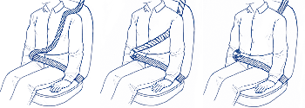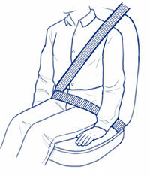

Seat Belt Myths—Excuses Don’t Work[8]

**MYTH: I don’t wear seat belts anymore, now that I have a car equipped with air bags.**

**FACT: Air bags are designed to work TOGETHER with your seat belt to keep you in a safe position in the event of a crash. Seat belts are designed to keep you in position for the vehicle’s other safety systems to work.**

**MYTH: I buckle up most of the time, but not if I am just going a few blocks to the store.**

**FACT: The risk of getting into a serious crash is just as great on a short trip. The majority of motor vehicle crashes occur within 25 miles of home and in areas where the speed limit is 4O mph or less. A crash at only 12 miles an hour can be fatal.**

**MYTH: I don't want to be trapped if the car catches fire or goes under water.**

**FACT: Less than one-half of one percent of crashes involves fire or submersion. Using seat belts prevents occupants from being knocked unconscious or into other passengers so that you can actually get out of the vehicle with the least amount of injury. Without a seat belt you are likely to be knocked out or too severely injured to leave the vehicle.**

**MYTH: Wearing a seat belt wrinkles my clothes.**

**FACT: Are you kidding? Wrinkles can be removed. The pain and suffering that accompany a serious crash cannot be easily ironed out. If wrinkles matter, change clothes at your destination.**

**MYTH: I want to be thrown clear to get out of harm’s way in the event of a crash.**

**FACT: Your chances of being killed are four times greater if you are thrown out of the vehicle. If you are ejected, you’re more likely to be killed by the trip through the windshield, by striking the ground or other surface 15O feet away, or by the vehicle rolling over you, than by the initial collision.**

**MYTH: Seat belts are too uncomfortable.**

**FACT: In a car crash—without your seat belt—you would smash into the steering column, slam into the dashboard or crash through the windshield; this is probably uncomfortable too.**

**MYTH: We'll never have a crash-Ply mom/dad is a good driver. I'm a good driver.**

**FACT: Good drivers can be hit by bad drivers, intoxicated drivers, aggressive or inattentive drivers. Wildlife or other sudden hazards may be impossible to avoid. Few people intend to have crashes.**

**MYTH: An adult's arms provide the best protection for a very small baby.**

**FACT: In a 20 mile-per-hour crash, a 10-pound baby can suddenly be ripped from a belted adult’s arms with a force of over 2OO pounds and launched into the dashboard. No matter how strong you are, you cannot hold on to a baby in a crash.**

**MYTH: I knew someone who died in a car crash because they were wearing their seat belt.**

**FACT: If a person was killed in a crash, it was not because they wore their seat belt, it was in spite of wearing their seat belt. The crash was most likely so severe and devastating, that only not being in that car at that moment would have prevented a fatality. A lap and shoulder belt worn properly, snug across the chest and pelvis, is the most effective injury prevention device you have at your command.**

**How To Get Started Organizing a Car Seat Checkup**

We all want our children to travel safely in vehicles. Installing a car seat for younger children can be a challenge. To receive assistance with your child passenger safety needs, it is recommended to connect with a nationally certified child passenger safety (CPS) technician(s) in your community. The technician(s) will check to make sure your car seats are installed correctly and teach you how to use and install a car seat on your own.

In some communities, certified CPS technicians are available to assist individuals or large groups of caregivers with their child passenger needs (also known as a car seat checkup). To arrange a safe and successful car seat checkup, it is very important to work with a certified CPS technician. Never offer a car seat checkup without a certified CPS technician.

The first step to take when planning a car seat checkup is to locate a CPS technician in or near your community. The technician should be able to assist you or refer you to someone else who can assist with arranging a checkup.

Here is how to locate a nationally certified CPS technician near you:

* Call the North Dakota Department of Health (NDDoH), Child Passenger Safety Program at 800.472.2286 or direct 701.328.4533. The NDDoH program director has a directory of all North Dakota certified CPS technicians and will be able to give you contact information for assistance. The department also assists technicians with offering community checkups.
* Find a technician through the National CPS Certification website:<https://ssl13.cyzap.net/dzapps/dbzap.bin/apps/assess/webmembers/tool?pToolCode=TAB9&pCategory1=TAB9_CERTSEARCH&Webid=SAFEKIDSCERTSQL>
* The National Highway Traffic Safety Administration (NHTSA) maintains a [directory](http://www.nhtsa.gov/apps/cps/index.htm) of many inspection stations; however this is a limited list and is not complete. Visit Parent Central: <http://www.safercar.gov/cpsApp/cps/index.htm>

**For Caregivers Attending a Checkup:**

There are a few things you should know before you meet with a CPS technician. This isn’t like getting an oil change on your vehicle, where you leave the vehicle and go do something else. Working with a CPS technician will be a one-on-one learning experience. When you leave, you should be confident that your child’s seat is installed correctly and feel comfortable reinstalling it on your own. This may be the most important thing you learn.

What Caregivers need to know about working with a CPS technician at a check-up.

**Before the Car Seat Checkup**

* Be prepared to learn, not just watch the CPS technician install the car seat. They're trained to teach you.
* If possible, know your child's weight and height, and bring your child with you.
* Install the seat in your vehicle before your car seat checkup. Be sure to use the instructions that came with the child car seat and the instructions in your vehicle owner’s manual regarding car seats.
* Bring the car seat instructions and the vehicle owner’s manual with you to your appointment.

**During the Car Seat Checkup**

* This one-on-one education typically takes 20-30 minutes per car seat, depending on your car seat and vehicle. The technician will take all the time you need until you feel comfortable that your car seat is used and installed correctly.
* During the checkup, a CPS technician will:
  + Fill out a form to note a variety of information, including the car seat type, location in vehicle and misuse observations, if any.
  + Ensure that your car seat is appropriate for your child’s age, and size, and review factors affecting proper use.
  + Review the car seat instructions and the vehicle owner’s manual to ensure that both are being followed correctly. (Remember to bring the vehicle owner’s manual with you.)
  + Ensure that an appropriate seating position in the vehicle is being used.
  + Check the car seat for recalls, visible damage and an expiration date.
  + Watch you install the car seat(s) correctly using either the seat belt or LATCH system.
  + Discuss the next steps for each child, such as when to graduate to the next type of car seat.
  + Answer any questions you may have.

Questions or need CPS educational materials? Contact the North Dakota Department of Health at 800.472.2286 for more assistance.

1. <https://www.dot.nd.gov/divisions/safety/docs/crash-summary.pdf>
2. <https://www.osha.gov/Publications/motor_vehicle_guide.pdf>
3. http://trafficsafety.org/road-safety-resources/public-resources/cost-of-motor-vehicle-crashes-to-employers-2015/
4. <http://www.cdc.gov/motorvehiclesafety/seatbeltbrief/>
5. https://www.osha.gov/Publications/motor_vehicle_guide.html
6. <http://www.cdc.gov/motorvehiclesafety/seatbeltbrief/>
7. <http://pubcit.typepad.com/clpblog/2014/02/the-massive-safety-effects-of-vehicle-regulations-and-seat-belts-in-particular.html>
8. <http://www.ndcodefortheroad.org/download/SeatBeltMyths.pdf>