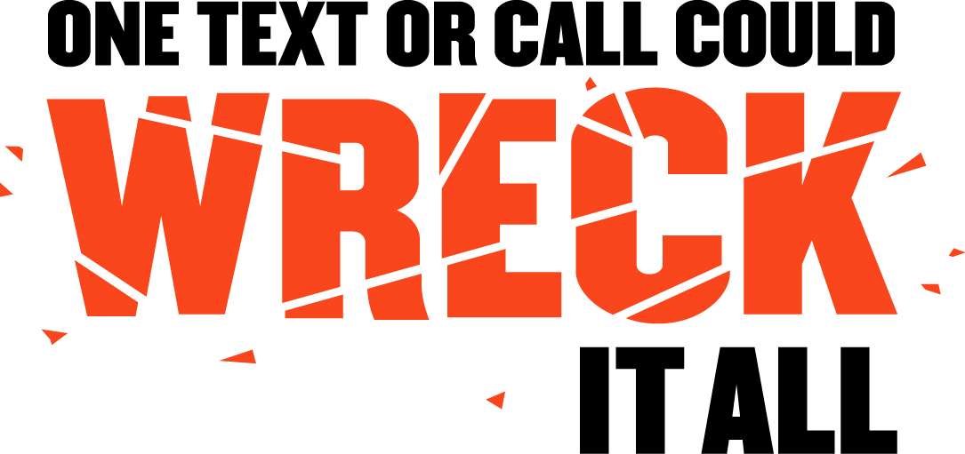
SAMPLE PRESS RELEASE
ANNOUNCING SUPPORT FOR
DISTRACTED DRIVING LEGISLATION

FOR IMMEDIATE RELEASE: [Date]
CONTACT: [Name, Phone Number, E-mail address]

Note: Before filling in the names of the organization and organization spokesperson, you MUST contact them to obtain their permission to use their names in this press release. You must get their approval for the language of their quotations and any changes or additions they may require. Only after this is done can you send out the press release.

[Name of Civic Group/Organization] Joins the
“One Text or Call Could Wreck It All” Campaign
Announces Support for Law Banning Texting and Hand-Held Cell Phone Use

[City, State] In an effort to make our roads safer, [Civic Group/Organization] announced today that they have joined the National Highway Traffic Safety Administration’s “One Text or Call Could Wreck It All” campaign to stop distracted driving. [Group/Organization] has pledged its support to help spread the message that distracted drivers are not only a danger to themselves, but to everyone else on the road. Through this campaign, they are encouraging [State] legislators to enact a law [or strengthen an existing law] banning texting and hand-held cell phone use while driving.

“We want to let people know we are serious about doing our part to stop this deadly behavior,” said [Organization/Group Official, Title]. “Too many people think that it’s okay to text or talk on the phone while driving, but tragedy after tragedy shows that these actions can have deadly consequences.”

In 2014 alone, 3,179 were killed and an estimated 431,000 were injured in motor vehicle crashes involving a distracted driver.

While anything that takes your eyes off the road, hands off the wheel, or mind off the task of driving is a hazard, there is heightened concern about the risks of texting while driving because it combines all three types of distraction – visual, manual and cognitive.

“These sad statistics reinforce the fact that passing a new law [or strengthening and enforcing an existing law] is critical to stopping distracted driving. It’s time for [STATE] to join the group of states that have already taken action,” said [Group Official].

“We want to encourage the [STATE] legislature to pass [or strengthen] [INSERT TYPE OF LAW] that will help keep our families, friends and communities safe,” [Official said]. “We cannot afford to allow this deadly behavior to continue.”

For more information on the “One Text or Call Could Wreck It All” campaign, and to find out how you can get involved, please visit [GROUP WEBSITE] or call [DESIGNATED PHONE NUMBER].

###

