SAMPLE NEWS RELEASE FOR
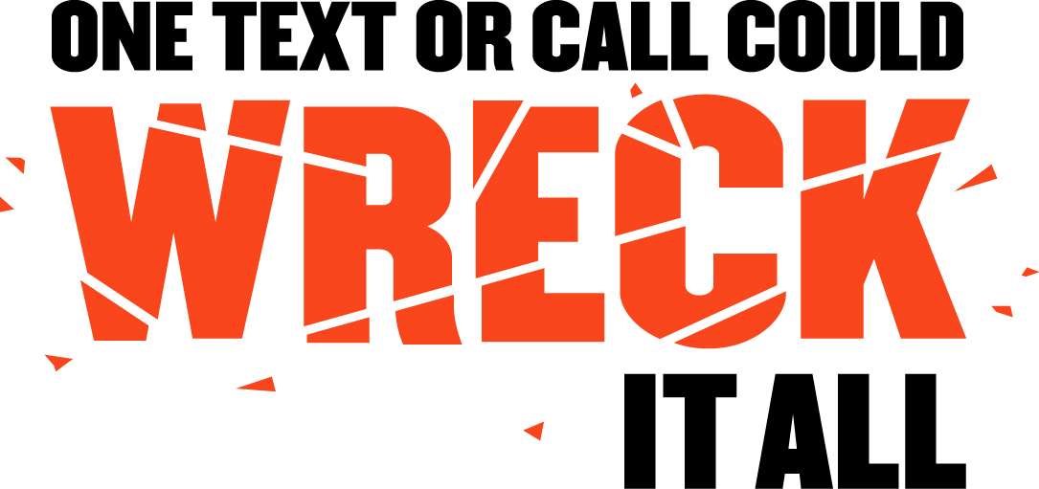
EMPLOYER DISTRACTED DRIVING
POLICY ANNOUNCEMENT

FOR IMMEDIATE RELEASE: [Date]
CONTACT: [Name, Phone Number, E-mail address]

Note: Before filling in the names of the organization and organization spokesperson, you MUST contact them to obtain their permission to use their names in this press release. You must get their approval for the language of their quotations and any changes or additions they may require. Only after this is done can you send out the press release.

[Your Company] Doing Its Part to Stop Distracted Driving
New Policy Banning Texting and Use of Cell Phones by Employees While Driving
Will Help Keep [Community] Safe

[City, State] – [Company Name] today announced its commitment to the safety of its employees and the [XX Community] community by enacting a new policy to help fight the epidemic of distracted driving. Effective [XX Date], company employees may not text or talk on a hand-held cell phone while in a company vehicle or in a personal vehicle with a company-issued cell phone.

“Employee safety is the number one priority of [Company Name],” said [Company Official]. “By creating this new policy, we hope to not only keep our employees safe, but to do our part as responsible members of the community. We hope everyone in [XX Community] will join us in making our community safer by putting their phones down and focusing on the road.”

Distracted driving is an epidemic on America’s roadways. In 2014, 3,179 people were killed and an estimated 431,000 were injured in motor vehicle crashes involving a distracted driver. Texting and cell phone use behind the wheel takes your eyes off the road, your hands off the wheel, and your focus off driving – putting the driver and others in danger.

“As anyone who has lost a loved one in a crash can tell you, even one traffic fatality is one too many. We are committed to eliminating this unnecessary risk and strongly believe that no conversation or text is worth the potential danger,” added [Company Official].

###

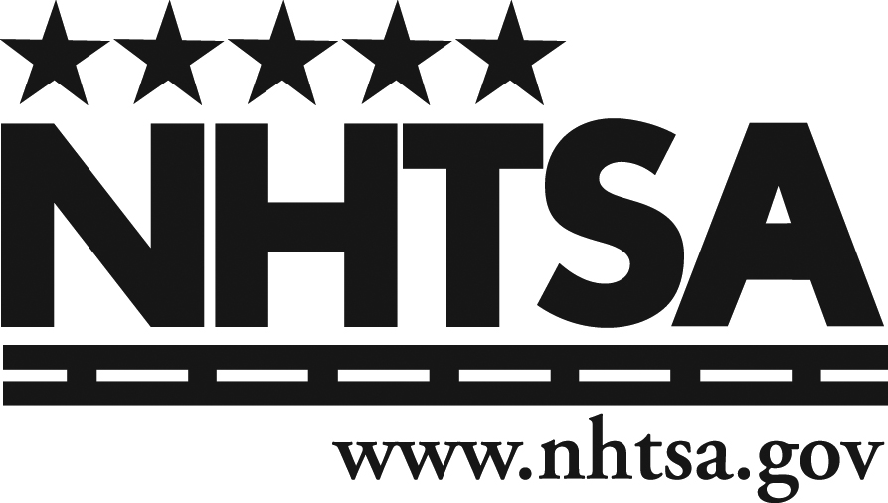
To learn more about the U.S. Department of Transportation and National Highway Traffic Safety Administration’s effort to stop distracted driving, please visit distraction.gov.

[Background information about your company]

