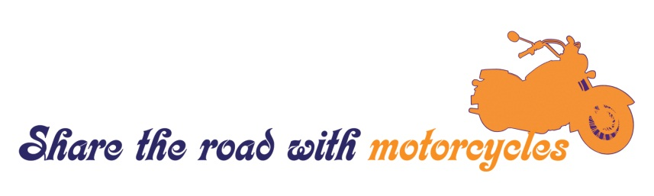
Motorcycle Safety Awareness Month 2015
SAMPLE social media Posts

Twitter
1) It’s #MotorcycleSafety Awareness Month. Join us and @NHTSAgov by encouraging drivers to “Share the Road.”
2) Do you share the road with motorcyclists? It’s #MotorcycleSafety Awareness Month. Help @NHTSAgov keep all road users safe.
3) In 2013, 4,668 motorcyclists were killed in crashes. Be extra alert for motorcyclists: Always share the road. #MotorcycleSafety
4) Motorcycles have the same rights as other vehicles, only they’re harder to see. Keep your distance. #MotorcycleSafety
5) 88,000 motorcyclists were injured in 2013. Protect yourself with a DOT-compliant helmet and reflective tape. #MotorcycleSafety
6) Never crowd motorcyclists. They need space to maneuver in case of an emergency or a sudden stop. #MotorcycleSafety
7) We want our roads to be safer for motorcyclists. That’s why we’re supporting @NHTSAgov’s “Share the Road” campaign. www.trafficsafetymarketing.gov/CAMPAIGNS/Motorcycle+Safety/Share+The+Road
8) Want to keep our roads safe? Help us and @NHTSAgov by encouraging drivers to share the road. http://www.trafficsafetymarketing.gov/CAMPAIGNS/Motorcycle+Safety/Share+The+Road #MotorcycleSafety
9) Did a #motorcycle just disappear from your rear view? Always check your mirrors and blind spots before changing lanes. #MotorcycleSafety
10) Your turn signal could save a life. Always use signals when changing lanes or merging into traffic. #MotorcycleSafety
11) Helmets saved 1,630 lives in 2013. Wearing a DOT-compliant helmet can make the difference. #MotorcycleSafety
12) If everyone riding a motorcycle had worn a helmet in 2013, an additional 715 lives could’ve been saved. #MotorcycleSafety
13) Whether you ride or drive, don’t make the deadly mistake of operating a vehicle after drinking alcohol. #MotorcycleSafety
14) In 2013, 41% of fatally injured motorcyclists were not wearing helmets at the time of the crash. #MotorcycleSafety
Facebook
1) The weather’s getting warmer, and motorcyclists will be out enjoying it. We’re supporting NHTSA’s “Share the Road” campaign during Motorcycle Safety Awareness Month. Help us make a difference: http://www.trafficsafetymarketing.gov/CAMPAIGNS/Motorcycle+Safety/Share+The+Road
2) Are you a rider? Help us help NHTSA save lives by promoting Motorcycle Safety Awareness Month. http://www.trafficsafetymarketing.gov/CAMPAIGNS/Motorcycle+Safety/Share+The+Road
3) Spring’s in the air and motorcyclists are out soaking up the season. Tragically, a joyride can quickly become a nightmare. Always wear a helmet when riding. Proper helmet usage saved 1,630 lives in 2013. http://www.nhtsa.gov/Safety/Motorcycles
4) In 2013, 4,668 motorcyclists died. We want to reduce that number to zero. It’s Motorcycle Safety Awareness Month – be extra alert and share the road. http://www.trafficsafetymarketing.gov/CAMPAIGNS/Motorcycle+Safety/Share+The+Road
5) Motorcycles have the same rights as other vehicles on the road, only they’re harder to see. Never crowd motorcyclists. Always give them the full lane. http://www.nhtsa.gov/Safety/Motorcycles
6) Give motorcyclists time to maneuver in case of an emergency or a sudden stop. A safe distance behind a motorcycle is 3-4 seconds. http://www.nhtsa.gov/Safety/Motorcycles
7) A great way for motorcyclists to be safe: Make yourself visible—wear bright clothing and reflective tape. http://www.nhtsa.gov/Safety/Motorcycles
8) Whether you’re a driver or a rider, never operate or ride a vehicle when distracted or impaired. http://www.nhtsa.gov/Safety/Motorcycles
9) Never assume motorcyclists are aware their turn signal is on. Signals on motorcycles are often non-canceling—they won’t switch off after a turn has been made. Always make sure the motorcycle turns before proceeding. http://www.nhtsa.gov/Safety/Motorcycles
10) Help us make every month of the year safe for motorcycles! This is #MotorcycleSafety Awareness Month: join us and NHTSA in sharing the road. http://www.trafficsafetymarketing.gov/CAMPAIGNS/Motorcycle+Safety/Share+The+Road
11) All road users, from the smallest motorcycle to the largest truck, have a responsibility to keep the roads safe. Help us spread the message: Share the road and keep a safe distance from motorcyclists. http://www.nhtsa.gov/Safety/Motorcycles
12) Are you a motorcyclist? Help us support NHTSA’s #MotorcycleSafety campaign by sharing the road and spreading the word: http://www.trafficsafetymarketing.gov/CAMPAIGNS/Motorcycle+Safety/Share+The+Road
13) Help us bring the 4,668 deaths of motorcyclists during 2013 down to zero. Make everymonth #MotorcycleSafety Awareness Month: Tell your friends and family to share the road! http://www.trafficsafetymarketing.gov/CAMPAIGNS/Motorcycle+Safety/Share+The+Road

