St. Patrick’s Day 2017 Social Media Messaging

NHTSA Buzzed Driving Is Drunk Driving Social Media Messages

Download the static infographics from the St. Patrick’s Day Traffic Safety Marketing page to include in these posts and tweets.

Instructions and descriptions are in red and should not be posted.

Twitter

From 2011-2015, 252 people died in drunk driving crashes over the St. Patrick’s Day holiday. #BuzzedDriving (insert 252 people infographic choice)
Example:
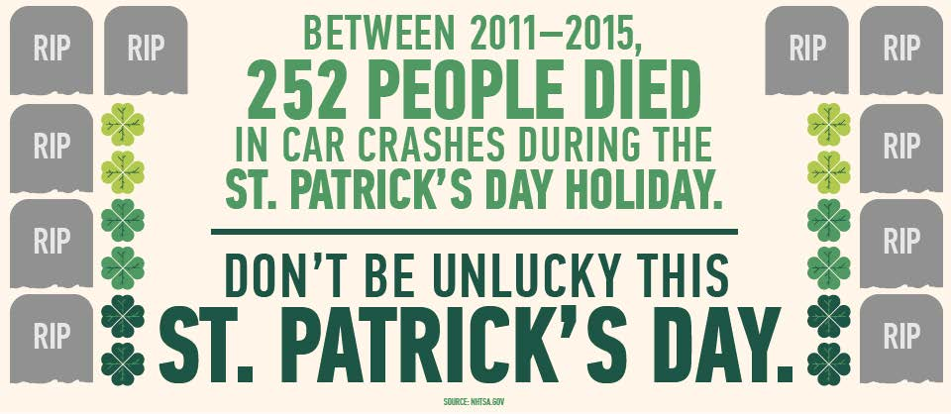

Don’t count on luck to get you safely home. Find a sober #designateddriver this St. Patrick’s Day. #BuzzedDriving

You’d be surprised how many people lose their lives to drunk drivers on St. Patrick’s Day. #BuzzedDriving

It’s not worth your life or the lives of others: find a sober #designateddriver this St. Patrick’s Day. #BuzzedDriving

Luck may be a lady…or a sober #designateddriver. Don’t drink and drive. #BuzzedDriving is #DrunkDriving

Don’t rely on a four-leaf clover to keep you safe this St. Patrick’s Day. #BuzzedDriving is #DrunkDriving

Be a friend’s lucky charm this St. Patrick’s Day and get them a sober ride home. #BuzzedDriving

You know what’s better than being a leprechaun this St. Patrick’s Day? Being a sober #designateddriver. #BuzzedDriving

Find a safe, sober ride home this St. Patrick’s Day. #BuzzedDriving is #DrunkDriving

In 2015, 31% of people who died in drunk driving crashes over St. Patrick’s Day were 21-34 years old. #BuzzedDriving

See how far your luck takes you – play @NHTSAgov’s “Last Call 360” experience. #BuzzedDriving https://www.nhtsa.gov/lastcall/

No four-leaf clover? Use @NHTSAgov’s free SaferRide app to get a sober ride home. #BuzzedDriving https://www.nhtsa.gov/drivesober/index.html

Try @NHTSAgov’s free SaferRide app to find a safe ride home this St. Patrick’s Day. #BuzzedDriving https://www.nhtsa.gov/drivesober/index.html

Facebook

In 2015, 31% of people who died in drunk driving crashes over St. Patrick’s Day were 21-34 years old, which was the highest percentage for any age group. #BuzzedDriving is #DrunkDriving

Over a five-year period, 53% of drivers involved in fatal crashes between midnight and 5:59 a.m. after St. Patrick’s Day were drunk. #BuzzedDriving

Be a good luck charm for friends this St. Patrick’s Day: be a sober #designateddriver and get yourself and friends home safely. #BuzzedDriving

It’s not worth your life. Make certain you drive sober this St. Patrick’s Day and every day of the year. #BuzzedDriving

Between 2011 and 2015, 252 people died in drunk driving crashes over the St. Patrick’s Day holiday. #BuzzedDriving is #DrunkDriving (insert 252 people infographic choice)
Example: 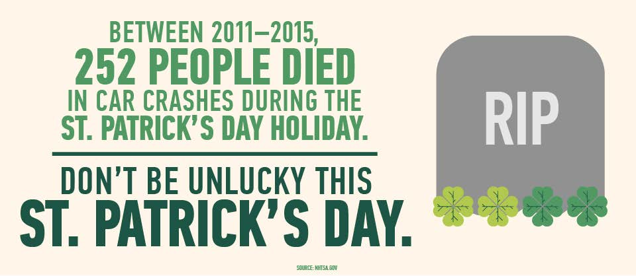

You’d be surprised how many people lose their lives to drunk drivers over the St. Patrick’s Day holiday. Don’t cost someone their life – drive sober. #BuzzedDriving is #DrunkDriving

Don’t count on a lucky charm to get you home safely this St. Patrick’s Day. Find a sober #designateddriver instead. #BuzzedDriving is #DrunkDriving

Need a bit of luck to get home safely? Try NHTSA’s free SaferRide app to find a sober ride home. #BuzzedDriving https://www.nhtsa.gov/drivesober/index.html

Get home safely this St. Patrick’s Day by using NHTSA’s free SaferRide app, designed to find you a sober ride home. #BuzzedDriving https://www.nhtsa.gov/drivesober/index.html

Try your luck in NHTSA’s “Last Call 360” experience. Where will the night take you? #BuzzedDriving www.nhtsa.gov/lastcall/

Instagram

Don’t be unlucky this St. Patrick’s Day. Ride with a sober #designateddriver. #BuzzedDriving is #DrunkDriving

You’d be surprised how many people are killed by drunk drivers on St. Patrick’s Day. Don’t be a statistic—ride with a sober #designateddriver. #BuzzedDriving is #DrunkDriving

Between 2011 and 2015, 252 people died in drunk driving crashes over the St. Patrick’s Day holiday. #BuzzedDriving is #DrunkDriving (insert 252 people infographic choice)
Example: 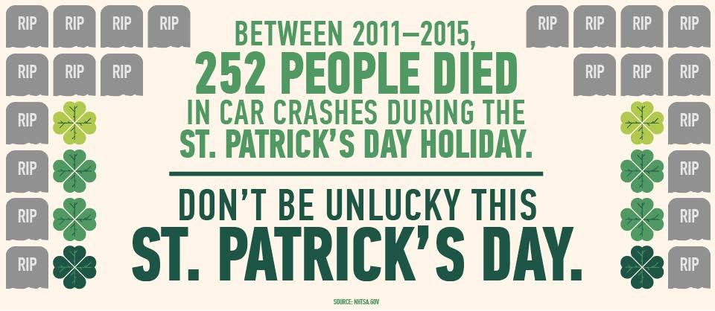

Find a sober #designateddriver this St. Patrick’s Day and every day of the year. #BuzzedDriving is #DrunkDriving

DYK? From 2011-2015, during the hours of midnight to 5:59 a.m. after St. Patrick’s Day, 53% of all drivers involved in fatal crashes were drunk. #BuzzedDriving is #DrunkDriving
12315d-020117-v1a
12315d-020117-v1

