Thanksgiving 2018 Social Media Messaging

NHTSA Thanksgiving Seat Belt Social Media Messages

Download the static infographics from the Buckle Up America Thanksgiving Safety Marketing page to include in these posts and tweets.

Instructions and descriptions are in red and should not be posted.

Twitter

DYK? Over the 2016 Thanksgiving holiday weekend, 49% of those killed in crashes weren’t buckled up. #BuckleUp http://ow.ly/6q3G30lBvpg (Insert NT14-66125 Thanksgiving_840x440_V1a_STATIC.jpg)
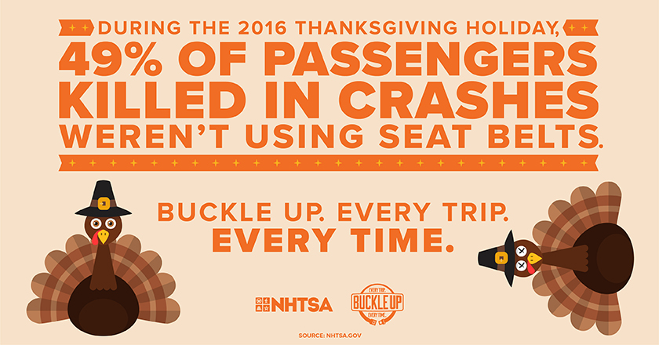

Over the 2016 Thanksgiving holiday weekend, 55% of those killed at night were unrestrained. #BuckleUp http://ow.ly/AoEr30lBvq2 (Insert NT14-66125 Thanksgiving_840x440_V1b_STATIC.jpg)
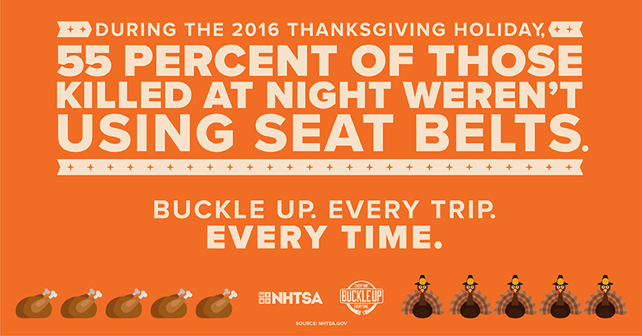

The road at night can be deadly, especially if you’re not wearing a seat belt. Always #buckleup! http://ow.ly/WCFR30lBvqQ

341 people died in traffic crashes over the 2016 Thanksgiving holiday weekend. Always #buckleup. http://ow.ly/m6Bo30lBvrG (Insert NT14-66125 Thanksgiving_840x440_V2b_STATIC-01.jpg)
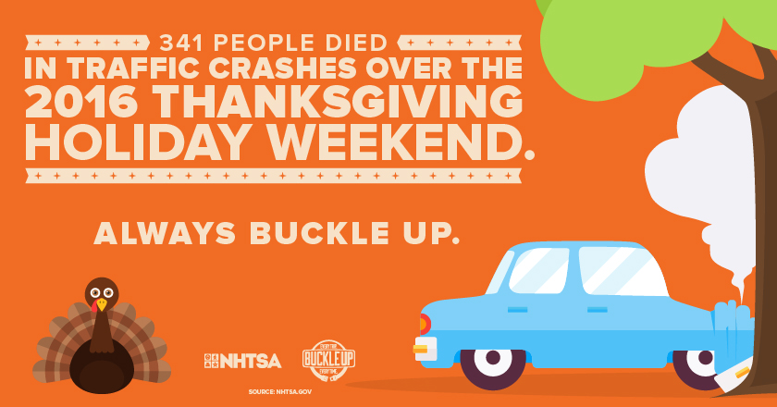

#DYK? Wearing your seatbelt drops your risk of fatal injury by 45%. #buckleup http://ow.ly/auFA30lBvsC (Insert NT14-66125 Thanksgiving_840x440_V2a_STATIC-01.jpg)
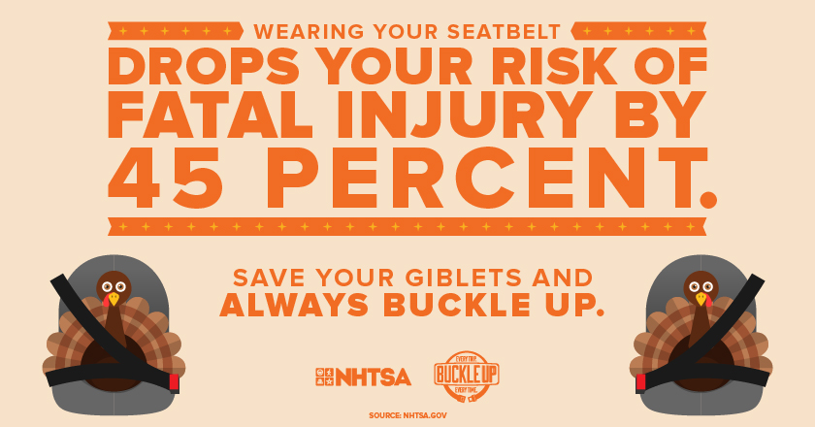

It takes two seconds to save your life: all you have to do is #buckleup. http://ow.ly/S7tv30lBvte

If you’re traveling this Thanksgiving holiday, make sure you’re wearing your seat belt. #buckleup http://ow.ly/xril30lBvuj

You have a lot to be thankful for – including your seat belt, one of the best lifesavers you could ask for. #bucklebp http://ow.ly/Yvq630lBvvh

Got family traveling for the holidays? Just remind them to #buckleup so they reach their destination safely. http://ow.ly/bbmz30lBvwW

Thanksgiving is one of the busiest travel weekends of the year – and one of the deadliest. #buckleup! http://ow.ly/WmMA30lBvxW

Driving without a seat belt can be deadly. Don’t ruin this Thanksgiving and the holidays to come: #buckleup. http://ow.ly/3shO30lBvyX

It’s cool to wear your seat belt. It’s okay, we asked. Don’t be a turkey this Thanksgiving: #buckleup. http://ow.ly/hbDc30lBvzO

Facebook

Over the 2016 Thanksgiving holiday weekend, 49% of those killed in crashes weren’t buckled up. This Thanksgiving and every day of the year, Buckle Up! http://ow.ly/5H5n30lBvBI (Insert NT14-66125 Thanksgiving_1200x628_V1a_STATIC.jpg)
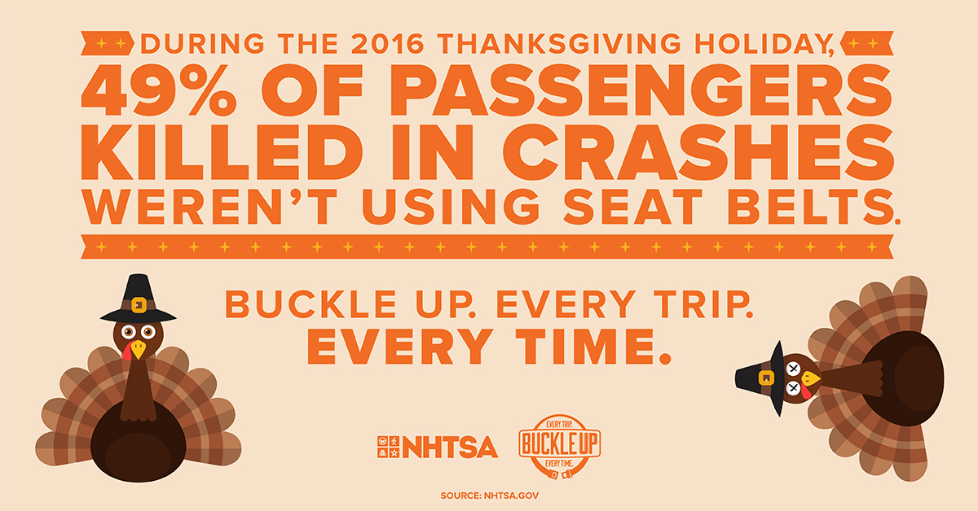

Don’t ruin your night. Over the 2016 Thanksgiving holiday weekend, 55% of those killed at night were unrestrained. Buckle Up: Every Trip. Every Time. http://ow.ly/3Xx230lBvDa (Insert NT14-66125 Thanksgiving_1200x628_V1b_STATIC.jpg)
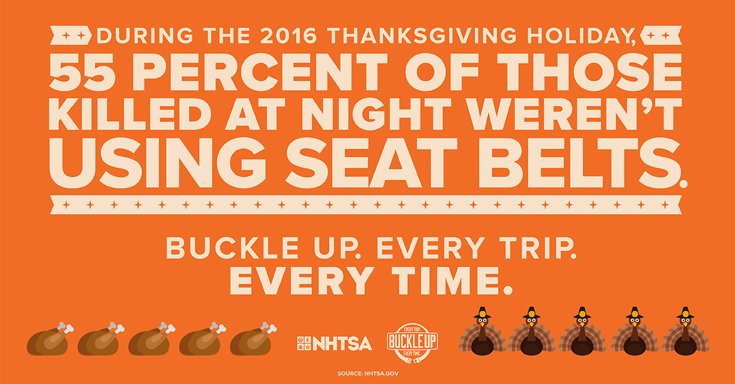

341 people died in traffic crashes over the 2016 Thanksgiving holiday weekend. Always buckle up. http://ow.ly/zsIg30lBvDT (Insert NT14-66125 Thanksgiving_1200x628_V2b_STATIC-01.jpg)
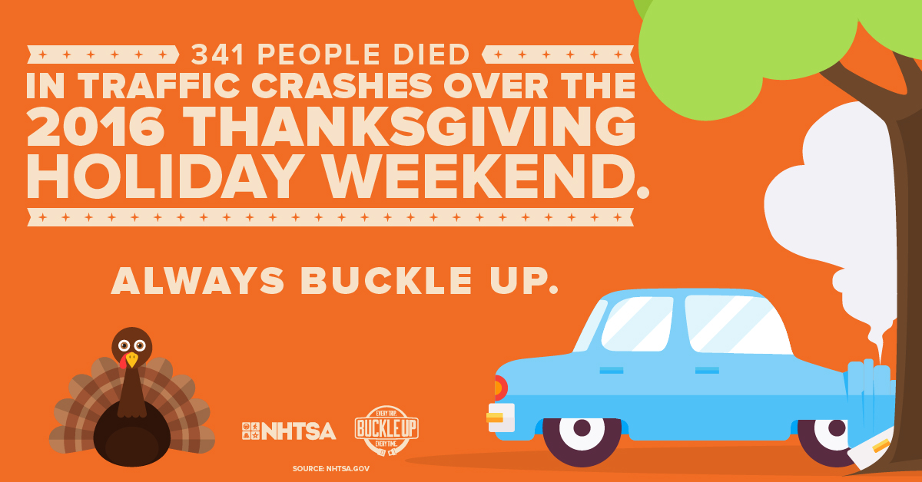

Did you know? Wearing your seatbelt drops your risk of fatal injury by 45 percent. Buckle up! http://ow.ly/8W8830lBvET (Insert NT14-66125 Thanksgiving_1200x628_V2a_STATIC-01.jpg)
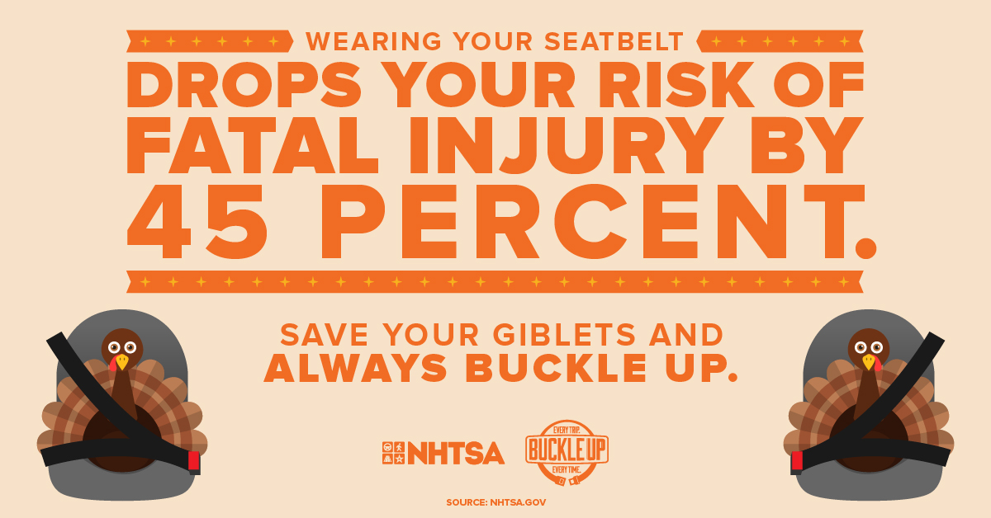

It takes just two seconds to click and save your life. Make sure that you’re buckling up this Thanksgiving and every day of the year. http://ow.ly/4Xz930lBvGo

Hey, don’t be a turkey: wear your seat belt this Thanksgiving and every day of the year! http://ow.ly/hP0j30lBvH8

Seat belts save thousands of lives every year. They can only save your life if you’re wearing one, though, so buckle up. http://ow.ly/VP6W30lBvIe

Got Thanksgiving travel plans to visit family? Make sure you’re wearing a seat belt. http://ow.ly/Ltp030lBvKu

Thanksgiving is one of the busiest travel weekends of the year – and one of the deadliest. Make sure you and your family are buckled up! http://ow.ly/IFfM30lBvLi

Don’t be a turkey: wear your seat belt every trip, every time. It could be the difference between life and death. http://ow.ly/KUJ130lBvMj

Instagram
(Note: Links cannot be shared in Instagram posts. If utilizing the links provided below, place the link in your bio and direct followers there with “Link in bio/profile” comment.)

Use this link: http://ow.ly/iz6430lBvNK

During the 2016 #Thanksgiving holiday, 49% of passengers killed in crashes weren’t using a #seatbelt. Always #BuckleUp! (Insert NT14-66125 Thanksgiving_1080x1080_V1a_STATIC.jpg)
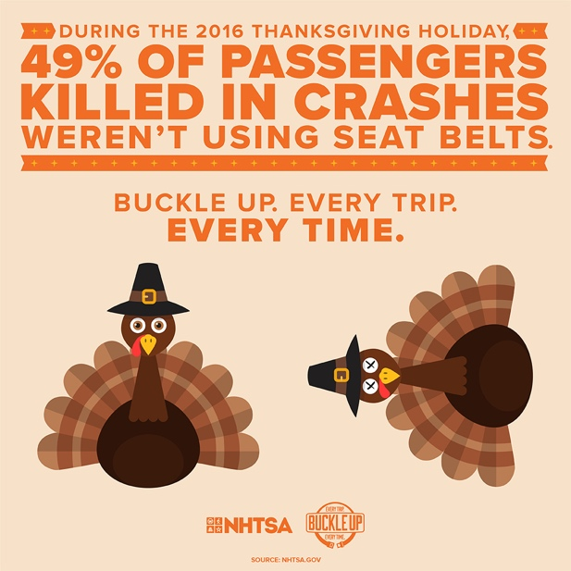

Don’t be a statistic this #Thanksgiving – always wear your #seatbelt and #BuckleUp! (Insert NT14-66125 Thanksgiving_1080x1080_V1b_STATIC.jpg)
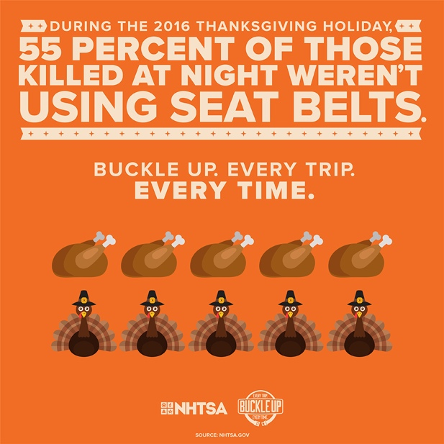

341 people died in traffic crashes over the 2016 Thanksgiving holiday weekend. Always #buckleup. (Insert NT14-66125 Thanksgiving_1080x1080_V2b_STATIC-01.jpg)
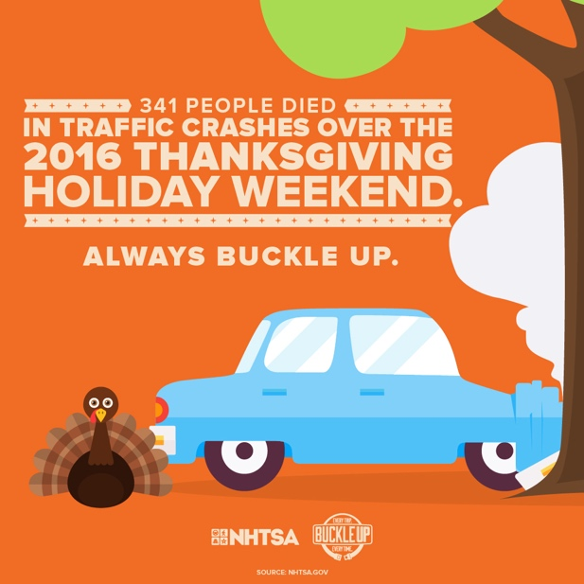

#DYK? Wearing your seatbelt drops your risk of fatal injury by 45 percent. #buckleup (Insert NT14-66125 Thanksgiving_1080x1080_V2a_STATIC-01.jpg)
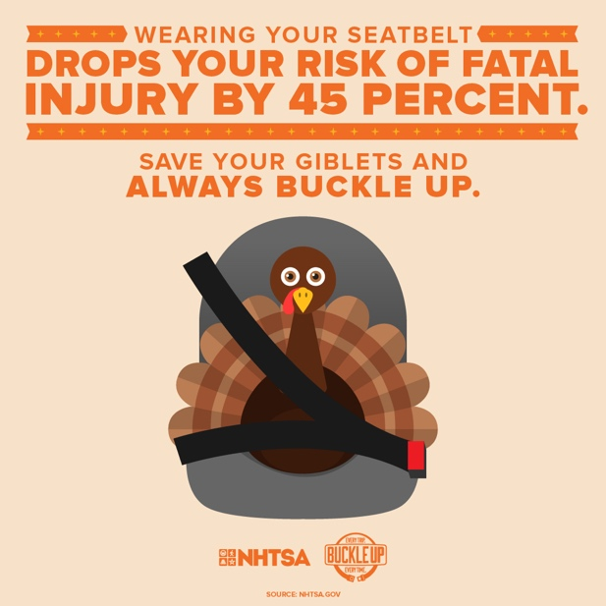

It takes two seconds to save your life: all you have to do is #buckleup. (Insert NT14-66125 Thanksgiving_1080x1080_V1a_STATIC.jpg)

A seat belt is a great way to save your life, but only if you wear it. Buckle up and protect yourself this Thanksgiving and every day of the year. #buckleup (Insert NT14-66125 Thanksgiving_1080x1080_V2b_STATIC-01.jpg)

Don’t be a turkey this Thanksgiving: just wear your seat belt every ride, every time. #buckleup (Insert NT14-66125 Thanksgiving_1080x1080_V2a_STATIC-01.jpg)

